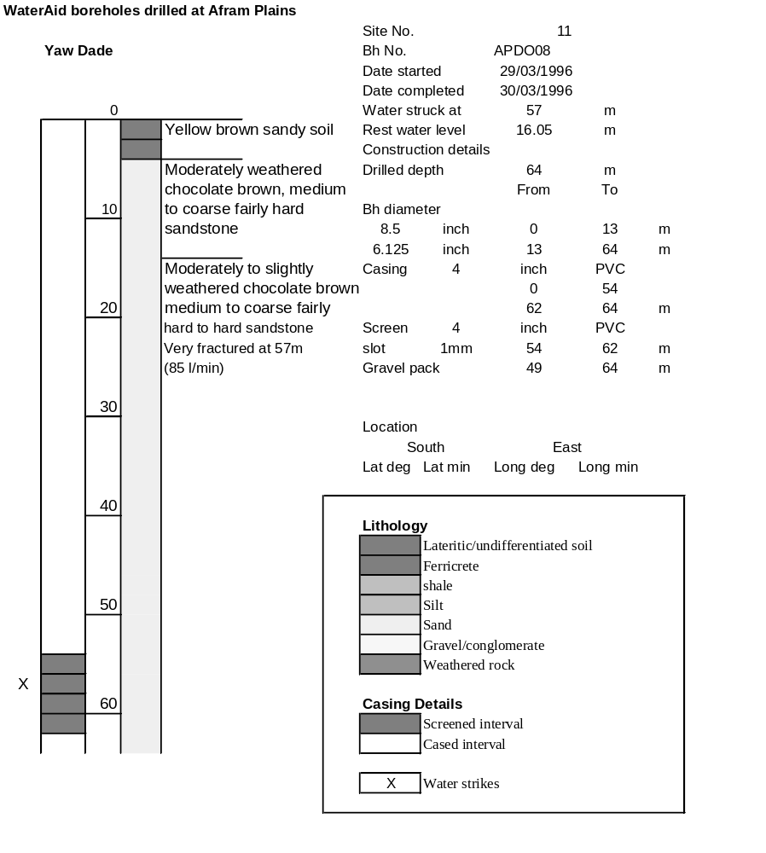

Ghana | Test pumping
Borehole No. |  | APDO8
Hole No |  | 11
Village |  | Yaw Dade
Date |  | 23/04/1996
Point above GL |  | 0.5 | m
Pump depth |  | 53 | m
SWL |  | 16.55 | m
Start Time |  | 08:40
Drawdown test |  |  |  |  | Recovery test
time | pwl (m) | Q l/min | dd | sc | Time | wl (m) | s' | t/t'
0.00 | 16.55 | 50.00 | 0.00 |  | 0.00 | 48.16 | 31.66
1.00 | 19.94 | 50.00 | 3.39 | 14.75 | 1.00 | 47.80 | 31.30 | 181.00
2.00 | 20.94 | 50.00 | 4.39 | 11.39 | 2.00 | 47.44 | 30.94 | 91.00
3.00 | 21.99 | 50.00 | 5.44 | 9.19 | 3.00 | 47.15 | 30.65 | 61.00
4.00 | 22.97 | 50.00 | 6.42 | 7.79 | 4.00 | 46.87 | 30.37 | 46.00
5.00 | 23.99 | 50.00 | 7.44 | 6.72 | 5.00 | 46.62 | 30.12 | 37.00
6.00 | 24.80 | 50.00 | 8.25 | 6.06 | 6.00 | 46.36 | 29.86 | 31.00
7.00 | 25.67 | 50.00 | 9.12 | 5.48 | 7.00 | 46.13 | 29.63 | 26.71
8.00 | 26.94 | 50.00 | 10.39 | 4.81 | 8.00 | 45.87 | 29.37 | 23.50
9.00 | 27.27 | 50.00 | 10.72 | 4.66 | 9.00 | 45.67 | 29.17 | 21.00
10.00 | 28.02 | 50.00 | 11.47 | 4.36 | 10.00 | 45.44 | 28.94 | 19.00
11.00 | 28.76 | 50.00 | 12.21 | 4.10 | 12.00 | 45.00 | 28.50 | 16.00
12.00 | 29.46 | 50.00 | 12.91 | 3.87 | 14.00 | 44.58 | 28.08 | 13.86
13.00 | 30.14 | 50.00 | 13.59 | 3.68 | 16.00 | 44.20 | 27.70 | 12.25
14.00 | 30.89 | 50.00 | 14.34 | 3.49 | 18.00 | 43.80 | 27.30 | 11.00
15.00 | 31.51 | 50.00 | 14.96 | 3.34 | 20.00 | 43.65 | 27.15 | 10.00
16.00 | 32.13 | 50.00 | 15.58 | 3.21 | 22.00 | 43.42 | 26.92 | 9.18
17.00 | 32.80 | 50.00 | 16.25 | 3.08 | 24.00 | 43.03 | 26.53 | 8.50
18.00 | 33.34 | 45.00 | 16.79 | 2.68 | 26.00 | 42.70 | 26.20 | 7.92
19.00 | 33.80 | 45.00 | 17.25 | 2.61 | 28.00 | 42.30 | 25.80 | 7.43
20.00 | 34.29 | 45.00 | 17.74 | 2.54 | 30.00 | 41.99 | 25.49 | 7.00
22.00 | 35.30 | 45.00 | 18.75 | 2.40 | 35.00 | 40.89 | 24.39 | 6.14
24.00 | 36.04 | 45.00 | 19.49 | 2.31 | 40.00 | 40.20 | 23.70 | 5.50
26.00 | 36.24 | 45.00 | 19.69 | 2.29 | 45.00 | 39.48 | 22.98 | 5.00
28.00 | 36.57 | 45.00 | 20.02 | 2.25 | 50.00 | 38.83 | 22.33 | 4.60
30.00 | 36.93 | 45.00 | 20.38 | 2.21 | 60.00 | 37.60 | 21.10 | 4.00
35.00 | 37.75 | 45.00 | 21.20 | 2.12 | 70.00 | 36.48 | 19.98 | 3.57
40.00 | 38.50 | 45.00 | 21.95 | 2.05 | 80.00 | 35.45 | 18.95 | 3.25
45.00 | 39.25 | 45.00 | 22.70 | 1.98 | 90.00 | 34.49 | 17.99 | 3.00
50.00 | 40.00 | 45.00 | 23.45 | 1.92 | 100.00 | 33.62 | 17.12 | 2.80
55.00 | 40.24 | 45.00 | 23.69 | 1.90 | 110.00 | 32.82 | 16.32 | 2.64
60.00 | 40.57 | 45.00 | 24.02 | 1.87 | 120.00 | 32.07 | 15.57 | 2.50
70.00 | 41.33 | 45.00 | 24.78 | 1.82
80.00 | 42.10 | 45.00 | 25.55 | 1.76
90.00 | 42.85 | 45.00 | 26.30 | 1.71
100.00 | 43.55 | 45.00 | 27.00 | 1.67
110.00 | 44.22 | 45.00 | 27.67 | 1.63
120.00 | 44.85 | 45.00 | 28.30 | 1.59
130.00 | 45.50 | 45.00 | 28.95 | 1.55
140.00 | 46.20 | 45.00 | 29.65 | 1.52
160.00 | 47.21 | 45.00 | 30.66 | 1.47
180.00 | 48.16 | 45.00 | 31.61 | 1.42
